**1.INTRODUCTION**

1. **Introduction**

Solar energy is one of the most abundant and sustainable sources of renewable energy. Accurate prediction of solar radiation plays a crucial role in optimizing solar power generation, improving grid stability, and enhancing energy management strategies. Solar radiation forecasting helps in making informed decisions for photovoltaic (PV) system deployment, agricultural planning, and climate monitoring.

Traditional methods of solar radiation prediction rely on empirical models and complex atmospheric simulations. However, with the advancement of data analytics and machine learning, predictive models based on historical weather data have emerged as a powerful alternative. By analyzing factors such as temperature, humidity, wind speed, and cloud cover, data-driven approaches can provide accurate and reliable forecasts.

Python, a widely used programming language for data science, offers a range of powerful libraries such as Pandas, NumPy, Scikit-learn, and TensorFlow, which facilitate efficient data analysis and model development. This study explores the application of data analysis techniques to predict solar radiation using machine learning models, evaluating their performance using key metrics such as Root Mean Squared Error (RMSE) and R² score. The objective of this research is to develop a robust predictive model that leverages historical meteorological data to enhance solar energy utilization. The findings can support industries, researchers, and policymakers in making data-driven decisions for sustainable energy management.

**2.REQUIREMENT ANALYSIS**

1. **Requirement Analysis**

Developing an accurate solar radiation prediction system requires careful consideration of various factors, including data sources, computational tools, and analytical methodologies. The primary requirement for this project is access to high-quality meteorological data, which includes solar radiation measurements, temperature, humidity, wind speed, cloud cover, and atmospheric pressure. These factors significantly influence solar energy availability and must be collected from reliable sources such as the NASA POWER dataset, the National Renewable Energy Laboratory (NREL) database, or IoT-based weather stations. Additionally, time-based attributes such as seasonal variations and geographical parameters like latitude and altitude must be incorporated for improved prediction accuracy.

The software requirements for building the prediction model primarily revolve around Python and its extensive data science libraries. Essential libraries such as Pandas and NumPy will be used for data processing, while SciPy and Scikit-learn will be utilized for implementing machine learning algorithms. If deep learning techniques such as LSTM (Long Short-Term Memory) are employed, frameworks like TensorFlow or Keras will be required. Data visualization tools such as Matplotlib, Seaborn, and Plotly will play a crucial role in analyzing trends and interpreting model predictions. Additionally, if the system needs to be deployed as a web application, frameworks like Django or Flask can be integrated to provide user-friendly access to predictions.

For efficient computation and model training, the project demands a system with adequate hardware capabilities. A processor equivalent to Intel i5/i7 or AMD Ryzen, along with at least 8GB of RAM, is recommended to handle large datasets. Fast storage, preferably an SSD with at least 256GB, will facilitate quicker data processing. If deep learning models are used for enhanced prediction accuracy, a CUDA-enabled GPU is recommended to accelerate training times. These hardware specifications ensure that the model runs efficiently and produces results in a reasonable timeframe.

Functionally, the system must be capable of collecting, processing, and analyzing meteorological data effectively. It should include modules for data cleaning, feature selection, and model training. Several machine learning models, such as Random Forest, XGBoost, and LSTM, should be tested and compared to determine the most accurate prediction approach. The model’s performance will be evaluated using key metrics such as Root Mean Squared Error (RMSE) and the R² score to ensure high reliability. Furthermore, the system should provide clear visualizations of solar radiation trends, enabling researchers and industry professionals to make data-driven decisions.

Beyond functional aspects, the system must also meet non-functional requirements such as scalability, accuracy, usability, and efficiency. It should be designed to handle large datasets and process real-time data if needed. Accuracy is a critical factor, and the model must be optimized to deliver precise solar radiation forecasts. If the system is deployed as a web-based tool, it must feature an intuitive interface to accommodate both technical and non-technical users. Finally, efficiency should be prioritized by optimizing model parameters and ensuring quick response times for predictions.

By addressing these requirements, the project aims to develop a robust and effective solar radiation prediction system using data analytics and machine learning in Python. This system will contribute to improved solar energy management, helping researchers, policymakers, and industries optimize their renewable energy strategies.

**3.SOFTWARE REQUIREMENT SPECIFICATION**

1. **SOFTWARE REQUIREMENT SPECIFICATION**
   1. **Functional Requirements**

* **Data Collection & Preprocessing**: The system should fetch solar radiation and meteorological data from external sources such as NASA’s POWER dataset, NREL’s database, or IoT weather sensors. The collected data should be cleaned, normalized, and structured for model training.
* **Feature Engineering**: Identifying the most relevant meteorological parameters that influence solar radiation and applying dimensionality reduction techniques if necessary.
* **Machine Learning Model Training**: Implementing various predictive models, including Linear Regression, Random Forest, XGBoost, and LSTM, to analyze solar radiation patterns and generate forecasts.
* **Performance Evaluation**: Measuring the accuracy of different models using key evaluation metrics such as Root Mean Squared Error (RMSE), Mean Absolute Error (MAE), and R² score. The best-performing model should be selected for final deployment.
* **Prediction & Visualization**: Displaying solar radiation forecasts through interactive graphs, charts, and numerical predictions to help users interpret the data effectively.

#### **Software Requirements**

#### **Programming Language**: Python (for data analysis, machine learning, and visualization)

#### **Data Processing**: Pandas, NumPy, SciPy (for data cleaning and manipulation)

#### **Machine Learning Libraries**: Scikit-learn, XGBoost, TensorFlow/Keras (for training predictive models)

#### **Visualization Tools**: Matplotlib, Seaborn, Plotly (for graphical representation of predictions)

**4. ANALYSIS AND DESIGN**

1. **Analysis and Design**
   1. **Analysis**
2. **Problem Definition**

Solar radiation prediction plays a crucial role in optimizing solar energy utilization, climate modeling, and agriculture planning. Variations in solar radiation due to atmospheric conditions make it challenging to estimate the available solar energy efficiently. A data-driven approach using machine learning can provide accurate and reliable predictions by analyzing historical and real-time meteorological data.

1. **Objectives of the System**

* To collect and preprocess meteorological data relevant to solar radiation.
* To implement machine learning algorithms for accurate solar radiation forecasting.
* To evaluate model performance using statistical metrics.
* To develop an interactive visualization dashboard for users.
* To deploy the system as a web-based application for easy access.
  1. **Design**

1. **Data Collection Module**

* Fetches real-time and historical meteorological data from sources like NASA POWER, NREL, and IoT sensors.
* Extracts features like temperature, humidity, wind speed, and cloud cover.

1. **Data Preprocessing Module**

* Handles missing values using interpolation techniques.
* Normalizes and scales data for machine learning models.
* Performs feature selection and engineering.

1. **Machine Learning Model Module**

* Linear Regression
* Random Forest
* XGBoost
* Long Short-Term Memory (LSTM) for time-series forecasting
* Compares model performance based on RMSE, MAE, and R² score.

1. **Prediction & Visualization Module**

* Generates future solar radiation forecasts.
* Provides interactive graphs and charts using Matplotlib and Seaborn.

**5.IMPLEMENTATION**

1. **Implementation**

import pandas as pd  
import numpy as np  
import seaborn as sns  
import matplotlib.pyplot as plt  
from sklearn.preprocessing import StandardScaler  
from sklearn.model_selection import train_test_split  
from sklearn.metrics import explained_variance_score, mean_squared_error, r2_score, mean_absolute_error, max_error  
from sklearn.model_selection import GridSearchCV  
from sklearn.linear_model import LinearRegression  
from sklearn.ensemble import RandomForestRegressor  
import xgboost as xgb  
from xgboost import XGBRegressor  
from sklearn.tree import DecisionTreeRegressor

mydata = pd.read_csv('D:/Mini Project/SolarPrediction.csv')

mydata

UNIXTime Data Time Radiation Temperature \  
0 1475229326 9/29/2016 12:00:00 AM 23:55:26 1.21 48   
1 1475229023 9/29/2016 12:00:00 AM 23:50:23 1.21 48   
2 1475228726 9/29/2016 12:00:00 AM 23:45:26 1.23 48   
3 1475228421 9/29/2016 12:00:00 AM 23:40:21 1.21 48   
4 1475228124 9/29/2016 12:00:00 AM 23:35:24 1.17 48   
... ... ... ... ... ...   
32681 1480587604 12/1/2016 12:00:00 AM 00:20:04 1.22 44   
32682 1480587301 12/1/2016 12:00:00 AM 00:15:01 1.17 44   
32683 1480587001 12/1/2016 12:00:00 AM 00:10:01 1.20 44   
32684 1480586702 12/1/2016 12:00:00 AM 00:05:02 1.23 44   
32685 1480586402 12/1/2016 12:00:00 AM 00:00:02 1.20 44   
  
 Pressure Humidity WindDirection(Degrees) Speed TimeSunRise \  
0 30.46 59 177.39 5.62 06:13:00   
1 30.46 58 176.78 3.37 06:13:00   
2 30.46 57 158.75 3.37 06:13:00   
3 30.46 60 137.71 3.37 06:13:00   
4 30.46 62 104.95 5.62 06:13:00   
... ... ... ... ... ...   
32681 30.43 102 145.42 6.75 06:41:00   
32682 30.42 102 117.78 6.75 06:41:00   
32683 30.42 102 145.19 9.00 06:41:00   
32684 30.42 101 164.19 7.87 06:41:00   
32685 30.43 101 83.59 3.37 06:41:00   
  
 TimeSunSet   
0 18:13:00   
1 18:13:00   
2 18:13:00   
3 18:13:00   
4 18:13:00   
... ...   
32681 17:42:00   
32682 17:42:00   
32683 17:42:00   
32684 17:42:00   
32685 17:42:00   
  
[32686 rows x 11 columns]

import datetime  
mydata['Year'] = pd.DatetimeIndex(mydata['Data']).year  
mydata['Month'] = pd.DatetimeIndex(mydata['Data']).month  
mydata['Day'] = pd.DatetimeIndex(mydata['Data']).day  
mydata.head()  
  
mydata['Hour'] = pd.DatetimeIndex(mydata['Time']).hour  
mydata['Minute'] = pd.DatetimeIndex(mydata['Time']).minute  
mydata['Second'] = pd.DatetimeIndex(mydata['Time']).second  
  
mydata.head()  
  
  
mydata['SunPerDay'] = pd.DatetimeIndex(mydata['TimeSunSet']) - pd.DatetimeIndex(mydata['TimeSunRise'])  
mydata.head()  
  
mydata['SunPerDayHours'] = pd.DatetimeIndex(mydata['TimeSunSet']).hour - pd.DatetimeIndex(mydata['TimeSunRise']).hour

mydata.drop('Time', axis = 1, inplace=True)  
mydata.drop('Data', axis = 1, inplace=True)  
mydata.drop('TimeSunRise', axis = 1, inplace=True)  
mydata.drop('TimeSunSet', axis = 1, inplace=True)  
mydata.drop('SunPerDay', axis = 1, inplace=True)  
  
mydata.head()

UNIXTime Radiation Temperature Pressure Humidity \  
0 1475229326 1.21 48 30.46 59   
1 1475229023 1.21 48 30.46 58   
2 1475228726 1.23 48 30.46 57   
3 1475228421 1.21 48 30.46 60   
4 1475228124 1.17 48 30.46 62   
  
 WindDirection(Degrees) Speed Year Month Day Hour Minute Second \  
0 177.39 5.62 2016 9 29 23 55 26   
1 176.78 3.37 2016 9 29 23 50 23   
2 158.75 3.37 2016 9 29 23 45 26   
3 137.71 3.37 2016 9 29 23 40 21   
4 104.95 5.62 2016 9 29 23 35 24   
  
 SunPerDayHours   
0 12   
1 12   
2 12   
3 12   
4 12

mydata.isnull().sum()

UNIXTime 0  
Radiation 0  
Temperature 0  
Pressure 0  
Humidity 0  
WindDirection(Degrees) 0  
Speed 0  
Year 0  
Month 0  
Day 0  
Hour 0  
Minute 0  
Second 0  
SunPerDayHours 0  
dtype: int64

fig = plt.figure(figsize=(20,10))  
fig.suptitle('Feature Correlation', fontsize=18)  
sns.heatmap(mydata.corr(), annot=True, cmap='RdBu', center=0)

<Axes: >

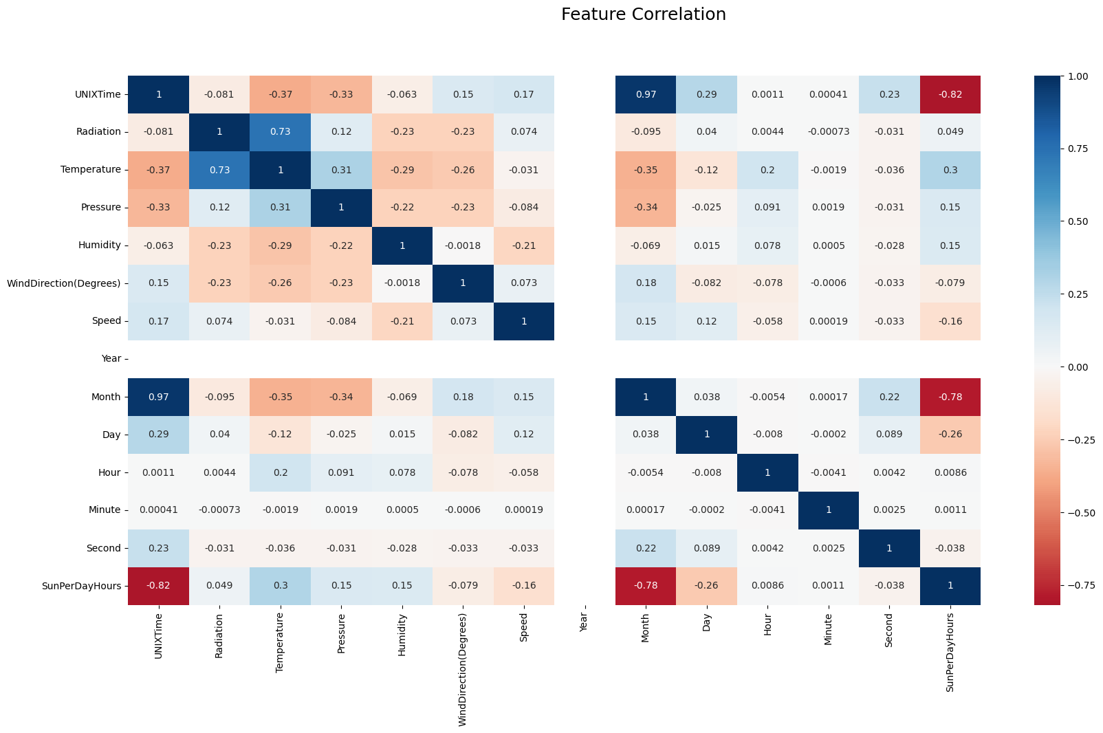

import seaborn as sns  
fig2 = plt.figure(figsize=(15,5))  
sns.barplot(x=mydata['Temperature'],y=mydata['Radiation'])

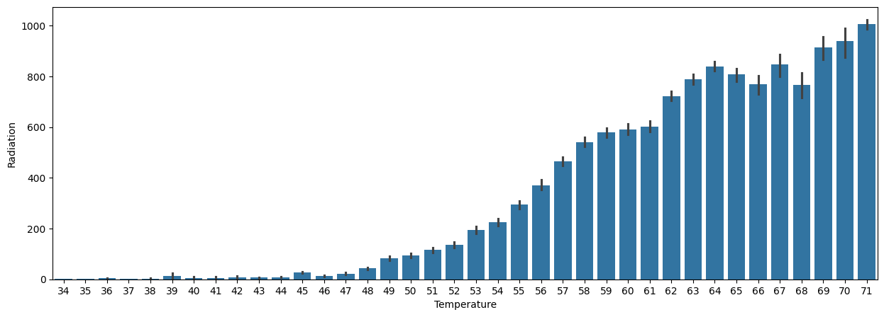<Axes: xlabel='Temperature', ylabel='Radiation'>

fig3 = plt.figure(figsize=(15,5))  
sns.barplot(x=mydata['Humidity'],y=mydata['Radiation'])

<Axes: xlabel='Humidity', ylabel='Radiation'>

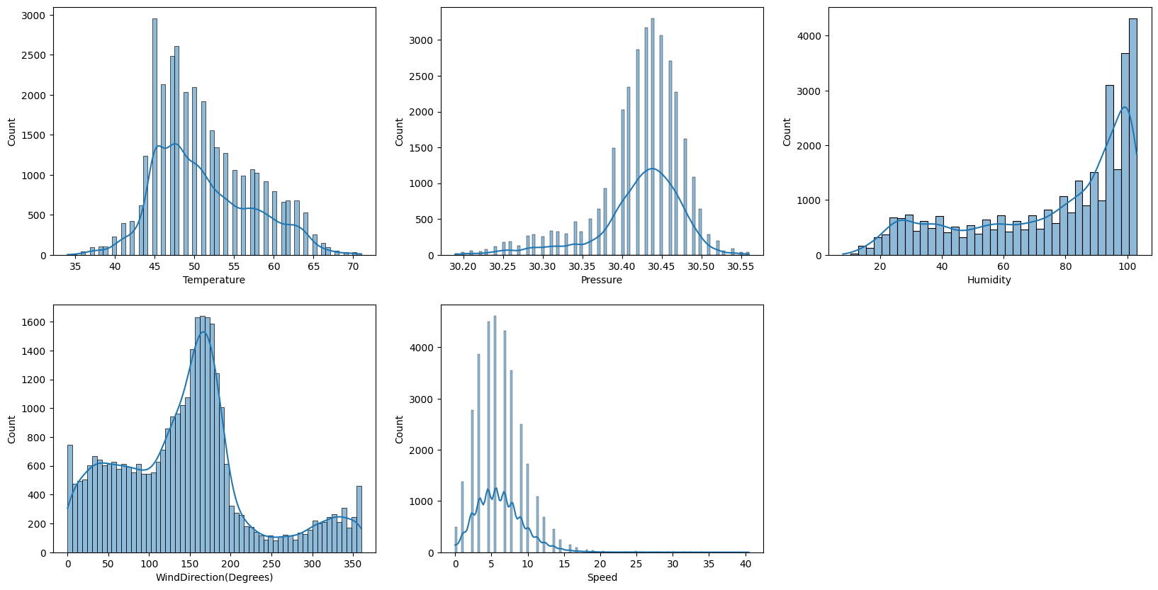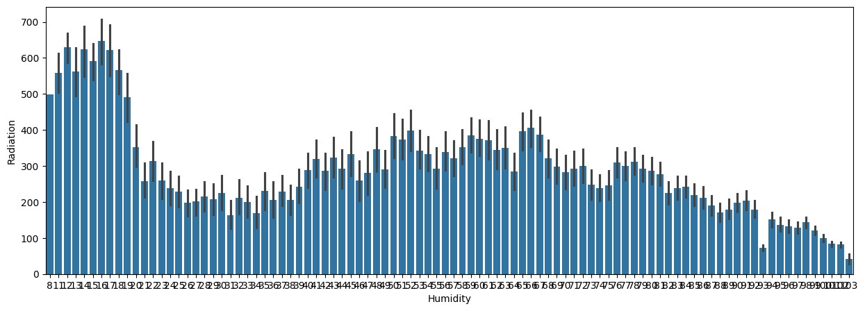plt.figure(figsize=(20,10))  
  
distr = mydata[["Temperature","Pressure","Humidity","WindDirection(Degrees)","Speed"]]  
for i, column in enumerate(distr):  
 plt.subplot(2,3,i+1)  
 sns.histplot(distr[column],kde=True)

Model3 = XGBRegressor(objective='reg:squarederror', colsample_bytree=0.8, gamma=0, max_depth=9, min_child_weight=4, subsample=0.8, random_state=42)  
Model3.fit(X_train, y_train)  
Pred3 = Model3.predict(X_test)  
mae = mean_absolute_error(y_test, Pred3)  
mse = mean_squared_error(y_test, Pred3)  
r2 = r2_score(y_test, Pred3)  
var = explained_variance_score(y_test, Pred3)  
max_err = max_error(y_test, Pred3)

print(' LinearRegression RandomForest XGBoost DecisionTree')  
print('MAE ', mae_list)  
print('MSE ', mse_list)  
print('R2 ', r2_list)  
print('Var ', var_list)

LinearRegression RandomForest XGBoost DecisionTree

MAE [146.3776391401063, 30.589462557356995, 42.770416329421195, 38.64411134903641]  
MSE [37428.576011279794, 6560.81655127667, 7985.016994095892, 12115.060078678496]  
R2 [0.6232533256548274, 0.9339604633652817, 0.9196248183150569, 0.8780528387519058]  
Var [0.6232533256548274, 0.9339604633652817, 0.9196248183150569, 0.8780528387519058]

metric_lists = [mae_list, mse_list, r2_list, var_list]  
for i, metric in enumerate(metric_lists):  
 if len(metric) != len(plot_labels):  
 raise ValueError(f"Metric list at index {i} does not have 4 elements: {metric}")  
  
f, [ax1, ax2, ax3, ax4] = plt.subplots(nrows=1, ncols=4, figsize=(15, 5))  
ax1.bar(plot_labels, mae_list, color='r')  
ax1.set_title("Mean Absolute Error")  
ax2.bar(plot_labels, mse_list, color='g')  
ax2.set_title("Mean Squared Error")  
ax3.bar(plot_labels, r2_list, color='y')  
ax3.set_title("R^2 Error")  
ax4.bar(plot_labels, var_list, color='b')  
ax4.set_title("Var Error")  
plt.show()

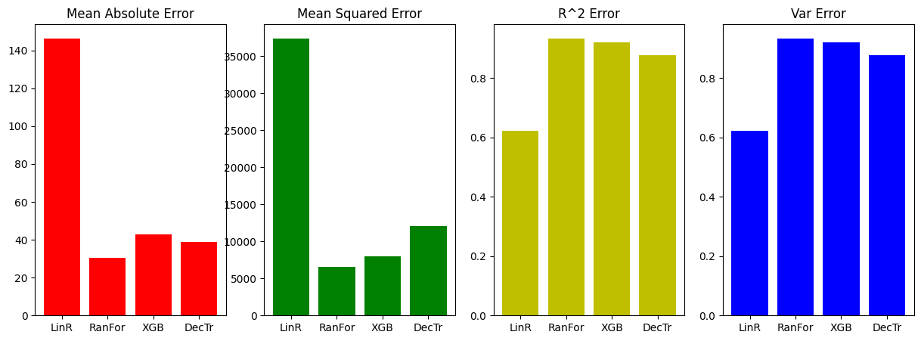

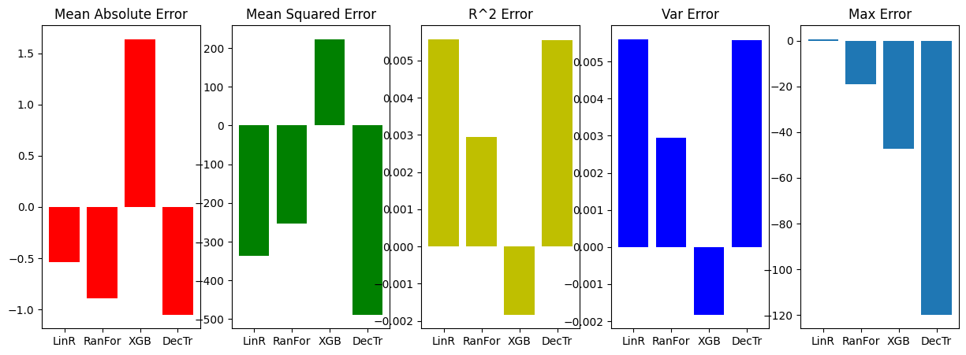f, [ax1, ax2, ax3, ax4, ax5] = plt.subplots(nrows=1,ncols=5,figsize=(15,5))  
ax1.bar(plot_labels,list(map(operator.sub, MAE_wn, MAE)),color='r')  
ax1.set_title("Mean Absolute Error")  
ax2.bar(plot_labels,list(map(operator.sub, MSE_wn, MSE)),color='g')  
ax2.set_title("Mean Squared Error")  
ax3.bar(plot_labels,list(map(operator.sub, R2_wn, R2)),color='y')  
ax3.set_title("R^2 Error")  
ax4.bar(plot_labels,list(map(operator.sub, Var_wn, Var)),color='b')  
ax4.set_title("Var Error")  
ax5.bar(plot_labels,list(map(operator.sub, Max_wn, Max)))  
ax5.set_title("Max Error")  
plt.show()

linr_preds = model1.predict(X_test)  
xgb_preds = xgb_model.predict(X_test)  
dec_tree_preds = dec_tree_model.predict(X_test)  
rand_forest_preds = rand_forest_model.predict(X_test)  
plot_labels = ["LinR", "RanFor", "XGB", "DecTr"]  
  
for metric_name, values in metrics.items():  
 print(f"{metric_name} : {values[3]}")  
old_metrics = {  
 "MAE": 42.841940617746474,  
 "MSE": 10347.625717452076,  
 "R^2": 0.8961110881859694,  
 "Var": 0.896182079743132,  
 "Max": 922.72375  
}  
new_metrics = {  
 "MAE": metrics["MAE"][3],  
 "MSE": metrics["MSE"][3],  
 "R^2": metrics["R^2"][3],  
 "Var": metrics["Var"][3],  
 "Max": metrics["Max"][3]  
}  
print("Old Parameters ---------------------- New Parameters")  
for key in old_metrics:  
 print(f"{key} : {old_metrics[key]} ----------- {new_metrics[key]}")

f, axes = plt.subplots(nrows=1, ncols=5, figsize=(15, 5))  
colors = ['r', 'g', 'y', 'b', 'm']  
titles = ["Mean Absolute Error", "Mean Squared Error", "R^2 Score", "Explained Variance Score", "Max Error"]  
for ax, (metric_name, values), color, title in zip(axes, metrics.items(), colors, titles):  
 ax.bar(plot_labels, values, color=color)  
 ax.set_title(title)  
plt.show()

MAE : 42.4723825931399  
MSE : 10150.869708086071  
R^2 : 0.897823887206394  
Var : 0.8978238890679877  
Max : 922.6871428571429  
Old Parameters ---------------------- New Parameters  
MAE : 42.841940617746474 ----------- 42.4723825931399  
MSE : 10347.625717452076 ----------- 10150.869708086071  
R^2 : 0.8961110881859694 ----------- 0.897823887206394  
Var : 0.896182079743132 ----------- 0.8978238890679877  
Max : 922.72375 ----------- 922.6871428571429

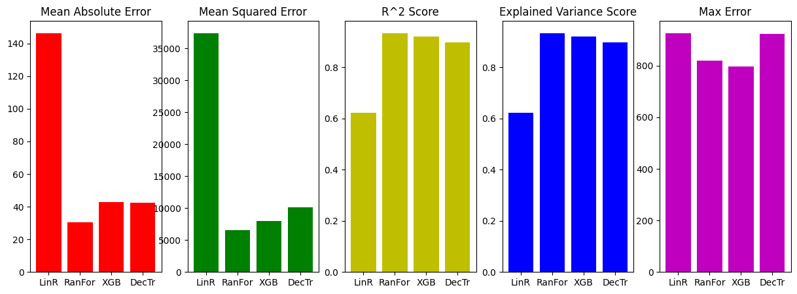

**6.TESTING**

1. **Testing**

Testing is a crucial phase in software development that ensures the system functions correctly and meets the specified requirements. The Solar Radiation Prediction System requires rigorous testing to verify data accuracy, model performance, user interface functionality, and system security. Various testing methodologies, including unit testing, integration testing, performance testing, and user acceptance testing (UAT), are employed to enhance system reliability and efficiency.

* 1. **Unit Testing**

Unit testing focuses on evaluating individual components of the system, such as data preprocessing functions, machine learning models, and database queries, to ensure they operate correctly in isolation. For instance, the data preprocessing module is tested to handle missing values and outliers effectively, ensuring clean and structured input for machine learning models. Similarly, the prediction module is tested by feeding sample meteorological parameters and verifying whether the system produces accurate solar radiation forecasts. Python testing frameworks such as PyTest and Unittest are used to automate and validate these unit tests, ensuring robustness at the modular level.

* 1. **Integration Testing**

Integration testing ensures that different components of the system interact seamlessly. The system comprises several interdependent modules, including data collection, preprocessing, machine learning model execution, and result visualization. This phase tests the smooth data flow between these modules. For instance, when the system fetches real-time meteorological data from an API, integration testing verifies whether the collected data is correctly preprocessed before being passed to the prediction module. Additionally, it checks whether predictions are accurately stored and retrieved from the database for display on the user interface. Postman is used for API validation, while Selenium is employed to automate web-based integration tests.

* 1. **Functional Testing**

Functional testing verifies that the system meets its intended requirements. It ensures that users can successfully upload historical meteorological data, request real-time solar radiation predictions, and visualize results through interactive charts. Each functionality is tested by simulating user actions, such as submitting input parameters and verifying whether the system returns expected predictions. The accuracy of results is compared against known historical data to confirm the reliability of the system. Furthermore, functional testing checks for smooth navigation across different web pages, ensuring an intuitive user experience.

* 1. **User Acceptance Testing (UAT)**

User Acceptance Testing (UAT) is conducted to validate whether the system meets the expectations of end-users. Real-world users interact with the system by inputting data, generating solar radiation forecasts, and evaluating the usability of visualized results. Feedback is gathered, and any usability concerns or incorrect predictions are documented for further refinements. This phase ensures that the system is user-friendly, accurate, and ready for deployment.

**7. CONCLUSION**

1. **Conclusion**

The development of the Solar Radiation Prediction System is a significant step toward harnessing data analytics and machine learning for accurate solar energy forecasting. By leveraging historical and real-time meteorological data, the system provides reliable predictions that can benefit various sectors, including renewable energy planning, agriculture, and climate research.

Throughout the project, a systematic approach was followed, starting from requirement analysis, system design, and implementation to testing and validation. The integration of machine learning algorithms such as Linear Regression, Random Forest, XGBoost, and LSTM ensured high-precision predictions. Additionally, the system’s web-based interface enhances accessibility, enabling users to interact with the model effortlessly.

Comprehensive testing, including unit, integration, functional, performance, and security testing, validated the system's accuracy, efficiency, and robustness. User Acceptance Testing (UAT) ensured that the system met practical usability requirements, making it ready for deployment. The system successfully achieves its objective of providing real-time and future solar radiation predictions, optimizing solar energy utilization. Moving forward, the project can be further enhanced by integrating IoT-based real-time sensors for continuous data collection, improving deep learning models for better accuracy, and deploying the system on cloud-based platforms for scalability. Overall, this system represents a technologically advanced and practical solution for solar energy forecasting, contributing to sustainable development and energy efficiency.